Horizon Europe – Widening Participation and Strengthening the European Research Area

What is Horizon Europe?
Horizon Europe is the EU’s key funding programme for research and innovation with a budget of €95.5 billion for the period 2021-2027. It tackles climate change, helps to achieve the UN’s Sustainable Development Goals and boosts Europe’s competitiveness and growth.
The programme facilitates collaboration and strengthens the impact of research and innovation in developing, supporting, and implementing EU policies while tackling global challenges. It supports the creation and better sharing of knowledge and technologies.
It also creates jobs, fully engages Europe’s talent pool, boosts economic growth, promotes industrial competitiveness, and optimises investment impact within a strengthened European Research Area.
For information on UK participation in the programme see UKRO’s dedicated factsheet.

What is the European Research Area?
The European Research Area (ERA) is the ambition to create a single, borderless market for research, innovation and technology across the EU.
Central to the ERA are the twin objectives of making the European Union the best and most successful environment for Research and Innovation, as well as ensuring that all Member States and their regions have the same opportunities to develop and access funding.
To make the European Research Area stronger, national research and innovation policies need to be strengthened too. Since 2010, the European Semester has been providing EU countries with recommendations to coordinate and improve social and economic policies across the EU. Research and innovation policy recommendations are embedded in this process.

What is the Widening Participation and Strengthening the European Research Area priority in Horizon Europe?
In addition to the three Pillars, Horizon Europe includes a fourth ‘transversal’ element that supports the overall objectives of the European Research Area (ERA), known as Widening Participation and Strengthening the European Research Area (WIDERA).
This fourth element is divided into two areas:
- Widening Participation and Spreading Excellence; and
- Reforming and Enhancing the European Research and Innovation System.
Widening Participation and Spreading Excellence provides actions targeted at reducing existing disparities between countries with higher R&I performances and countries with lower R&I performances (‘Widening Countries’) to enable the ERA to advance as a whole. This area is designed to specifically respond to the second policy priority of the ERA communication, improving access to excellence as well as developing stronger R&I systems across the whole of the EU. It also builds on complementarities with the smart specialisation strategies under the Cohesion Policy and synergies with other Horizon Europe measures.
The key objectives of this area include:
- Encouraging institutional reforms and transformation processes of the R&I system at the national and regional level in Widening countries in line with ERA principles.
- Mobilising national investments in R&I capacity in Widening countries.
- Raising the bar for the excellence of R&I actors in Widening countries in partnership with outstanding European and international institutions (‘win-win situation’).
- Increasing the number of participations and success rates of Widening actors in research and innovation projects in other parts of Horizon Europe (notably in Pillars 2 and 3).
- Promoting the creation of new innovation ecosystems and the scaling up of existing ones, by a set of measures, which include but are not limited to place-based and international collaboration between academia and business in Widening countries.
- Fostering brain circulation, including inter-sectoral mobility for researchers and innovators and turn it into brain gain for Widening countries.
Reforming and enhancing the European Research and Innovation system will address themes such as Responsible Research and Innovation (RRI), Gender Equality and Open Science. This area sets out to reform and enhance the EU R&I system in line with the objectives of the ERA Communication which include prioritising investment and reforms, improving access to excellence, translating R&I results into the economy, and deepening the ERA.

What will be funded under this part of Horizon Europe?
To help reduce existing disparities between research and innovation-leading and lagging countries, structural policy reforms are needed as well as strengthened links between R&I and institutional cooperation. In addition, building on existing pockets of excellence and connecting them to broader networks of excellence, countries that have underperformed in previous Framework Programmes (‘Widening Countries’) will be able to upgrade their R&I systems, making them stronger and enabling the ERA to advance.
The WIDERA 2025 work programme covers a wide range of activities including enhancing R&I capacity, supporting national reforms, facilitating researcher mobility, measures to promote excellence, support for the creation of new collaborative networks across the EU and support to open established networks to applicants from Widening countries. The aim is to increase the R&I profile of Widening countries and enhance their participation in other actions under Horizon Europe.
The work programme will also directly contribute to achieving the Horizon Europe expected impacts along the four key strategic orientations set in the Horizon Europe Strategic Plan. It will also directly contribute to supporting the implementation of key policy objectives of the European Commission, particularly the EU’s competitiveness, the European Green Deal and the EU’s digital strategy.

Destination: Improved Access to Excellence
- HORIZON-WIDERA-2025-01-ACCESS-01: European Excellence Initiative – These projects will increase cooperation in and between alliances of higher education institutions, such as, but not limited to, the European Universities alliances selected under Erasmus+, with a particular focus on Widening countries.
- HORIZON-WIDERA-2025-02-ACCESS-01: EIC pre-accelerator – This call will increase the innovation potential of deep-tech startups in the widening countries and enable them to better attract private investments and scale up.
- HORIZON-WIDERA-2025-03-ACCESS-01: Hop-On Facility – Designed to improve the capacities of low research and innovation-performing countries by enabling them to join already selected collaborative projects funded under Pillar 2, provided that there are no current Widening countries participating in it.
- HORIZON-WIDERA-2025-04-ACCESS-01: Support for R&I policy making in the EU enlargement countries – This call will provide support to national and regional R&I and education initiatives by pooling resources and contributing to the alignment of national and regional research, innovation, and education policies for Albania, Bosnia and Herzegovina, Georgia, Kosovo, Moldova, Montenegro, North Macedonia, Serbia, Türkiye, and Ukraine.
- HORIZON-WIDERA-2025-05-ACCESS-01: Implementing co-funded action plans for connected regional innovation valleys in widening countries – This call will create connected regional innovation valleys across the EU, involving regions with lower innovation performances, by building on strategic areas of regional strength and specialisation (defined in their smart specialisation strategies), in support of key EU priorities. Regions represented by successful applicant national or regional authorities under this call will be recognised as “regional innovation valleys”.

Destination: Reforming and enhancing the European research and innovation system
- HORIZON-WIDERA-2025-06-ERA-01: Rolling out the ERA Policy Agenda results – This call will increase uptake by broad communities of R&I stakeholders of results developed in different ERA policy areas, including open science, research assessment, research careers, knowledge valorisation, and research management.
- HORIZON-WIDERA-2025-06-ERA-02: Enable sustained coordination and guidance at the European level on institutional non-profit open access publishing – This call will deliver sustainable high quality institutional non-profit open access publishing services indexed in research information systems adhering to national research assessment standards. It will also increase capacity in the EU R&I system to conduct open science and establishing it as the prevailing approach in modern research approaches.
- HORIZON-WIDERA-2025-06-ERA-03: Research and innovation to provide evidence that support reforms of research assessment – This call will deliver a more responsible assessment of researchers, research projects and research organisations based on a broader range of research outputs, practices and activities than publications and publishing. It will also improve the quality, performance and impact of research, researchers and institutions due to more responsible research assessment systems.
- HORIZON-WIDERA-2025-06-ERA-04: Investigating and addressing career barriers faced by underrepresented and marginalised researchers – This call will strengthen gender equality and inclusiveness in the European Research Area.
- HORIZON-WIDERA-2025-06-ERA-05: Programme-level collaboration – This call will deliver common priority setting and sustainable joint activities and funding programmes among national and regional research and innovation programmes by pooling national and regional resources and aligning national and regional research and innovation policies, with the overall aim to enhance collaborative R&I efforts to address global challenges.
- HORIZON-WIDERA-2025-06-ERA-06: Strengthening of the European Science for Policy Ecosystem – This call will deliver a more robust and interconnected European Science for Policy (S4P) ecosystem that better supports evidence-informed policymaking across sectors and governance levels by increasing the connectivity and mainstreaming of S4P actors and networks.
- HORIZON-WIDERA-2025-06-ERA-07: Science comes to town 2027 – This call provides an opportunity for cities in Member States and Associated Countries to take centre stage in increasing societal responsibility and trust in science and innovation by engaging stakeholders, local communities and citizens in the design and implementation of R&I policies and by enhancing communication of science to the public.

Other actions not subject to calls for proposals
The work programme will also support direct grants to identified beneficiaries and other public procurement actions. These include but are not limited to:
- Presidency conferences with a European regional dimension – WIRE 2026.
- Development of new functionalities and maintenance of the one-stop-shop on tackling R&I foreign interference.
- Implementation of ERA monitoring.
- Administrative management of the Human Resources Strategy for Researchers (HRS4R).
- Implementation of the Horizon Policy Support Facility – Framework contract 2025-2029.

Widening Countries

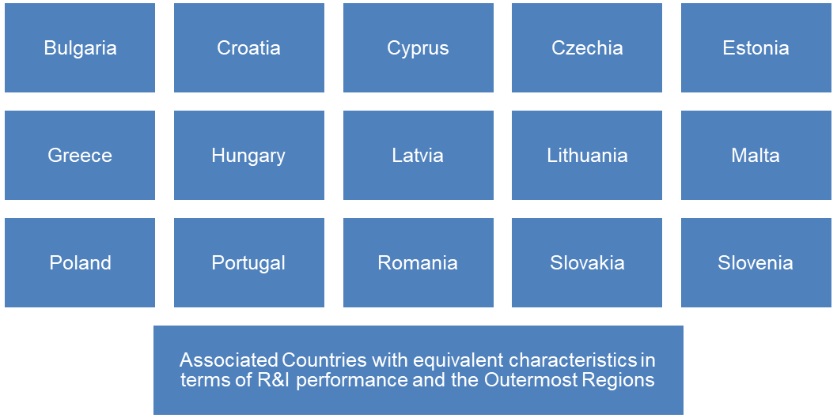

Relevant EU policy areas and developments
The ERA Communication is a key policy area which underpins the Widening Participation and Strengthening the European Research Area work programme, and the WIDERA calls will directly contribute to its four key objectives. Moreover, the work programme will contribute to achieving Horizon Europe's expected impacts along the four key strategic orientations set in the strategic plan and support the implementation of key policy objectives of the European Commission notably the European Green Deal and the EU’s digital strategy. The Widening participation work programme will contribute de facto to all SDGs, but directly to the following: SDG 4 - Quality Education; SDG 5 - Gender Equality; SDG 9 - Industry, Innovation and Infrastructure; SDG 17 - Partnership for the Goals. Projects should also actively seek synergies with other relevant EU, national or regional programmes.

More information
- Horizon Europe website
- Widening Participation and Strengthening the European Research Area Work Programme 2025
- Widening Participation and Strengthening the European Research Area Work Programme 2023-2025
- The European Research Area (ERA)
- European Strategy for Universities
- WIDERA NCP project (NCP_WIDERA.NET)
Horizon Europe’s legal basis:
- Regulation establishing Horizon Europe
- Decision establishing the Specific Programme of Horizon Europe
- First Strategic Plan for Horizon Europe (2021-2024)
- Second Strategic Plan for Horizon Europe (2025-2027)
UKRO Portal
- UKRO Portal
- WIDERA UK NCP

